DAY 16 REPORT
Task Name: Power BI Dashboard Creation and Visualization for Student Dataset
Introduction
Power BI is a business analytics and data visualization tool used to create interactive dashboards and reports. It helps in analyzing datasets using charts, graphs, KPI cards, and visual themes for better understanding of information.

Dashboard Features Used
- Bar Chart for grade comparison
- Line Chart for weekly self-study hours analysis
- Pie Chart for subject percentage distribution
- KPI Card for displaying total study hours
- Customized lavender dashboard theme
- Visual background and chart color customization
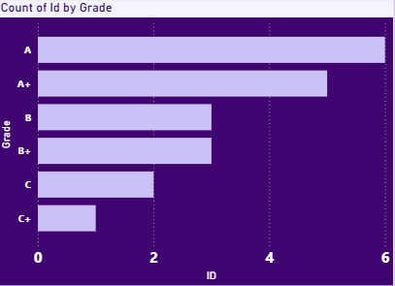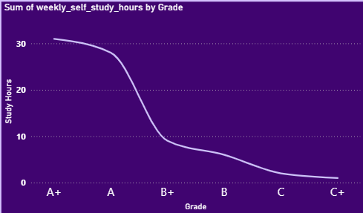
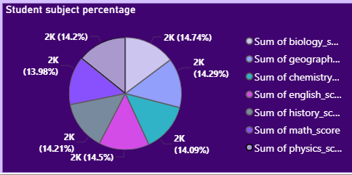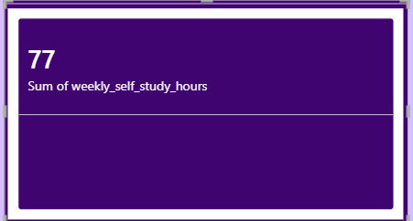

Theme Customization
- Overall Background Color → #EEE6FF
- Visual Background Color → #3B0764
- Bar Color → #C4B5FD
- Title Color → #F5F3FF
- Axis Color → #DDD6FE
- Border Color → #7C3AED
OVERALL ANALYSIS:
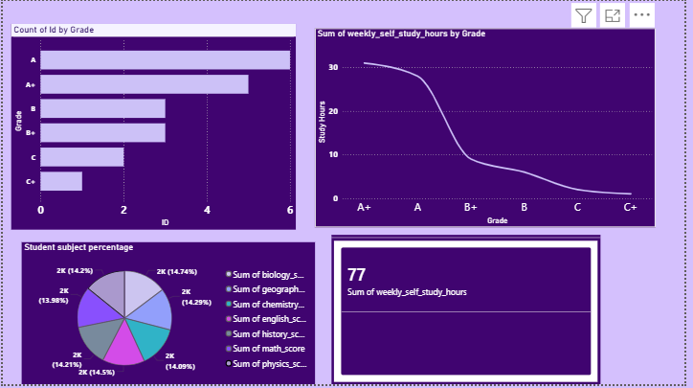

Conclusion
On Day 16, created an interactive Power BI dashboard using different visualizations such as bar chart, line chart, pie chart, and KPI card. Also learned how to customize dashboard themes, background colors, and visual formatting to improve the appearance and readability of reports.

